SIMATS ENGINEERING
ASSESSMENT TOOL 2

COURSE CODE: CSA14 COURSE NAME: COMPILER DESIGN

COURSE OUTCOME COVERED

CO3: Analyze syntax-directed translation method using synthesized and inherited attributes to generate a Parser Tree. (BL4)

Assessment Tool Weightage: 20%

QUESTIONS: Total Marks:100

Annexure A

Debugging

Code of Conduct:

I Arunprasath R 192524077(Name / Reg No) certify that this submission is my original work and that I have adhered to the guidelines specified for this assessment.
I understand that any violation of academic integrity rules will result in disciplinary action.

Signature of the student:
Arunprasath R

Q. No | Understanding of Debugging Concepts (25) | Error Identification(25) | Root Causes Analysis (20) | Error Corrections and Solution Design(20) | Testing and Validation(10) | Total Score  (out of 100)
1 | / 4 | / 4 | / 4 | / 4 | / 4
2 | / 4 | / 4 | / 4 | / 4 | / 4
3 | / 4 | / 4 | / 4 | / 4 | / 4
4 | / 4 | / 4 | / 4 | / 4 | / 4
5 | / 4 | / 4 | / 4 | / 4 | / 4
OVERALL RUBRICS VALUE
 | / 4 | / 4 | / 4 | / 4 | / 4
 | / 25 | / 25 | / 20 | / 20 | / 10 | / 100

Annexure A

Debugging
Q1 Consider the following syntax-directed definition:
E → E1 + T ( E.val = T.val }

E → T { E.val = T.val }

T → num { T.val = num.lexval }
For the input:
3 + 5
the compiler produces:
E.val = 5
Debug the given syntax-directed definition. Identify the incorrect semantic rule, explain its effect on attribute evaluation, provide the corrected rule, and determine the correct value of the expression.
Q2 . For the expression:
a + b * c
the compiler constructs the following syntax tree:
*
/ \
+ c
/ \
a b
The compiler subsequently generates:
t1 = a + b
t2 = t1 * c
Debug the syntax-tree construction. Analyze the relationship between operator precedence and the generated tree, construct the corrected syntax tree, and generate the correct intermediate representation.
Q3. For the expression:
3 + 4 * 5
using:
E → E + T | T
T → T * F | F
F → num
the compiler annotates the root with:
E.val = 35
Analyze the annotated parse tree. Trace the synthesized attributes from the leaves to the root, identify the incorrect computation, and determine the correct value of the expression.
Q4 . The symbol table contains:
Identifier | Type
a | int
b | float
c | int
x | float
For the statement:
x = a + b * c;
the compiler reports:
Type Error: incompatible operands
Debug the type-checking process. Analyze each subexpression, determine the type of b * c and a + (b * c), identify where type conversion is required, and determine whether the assignment to x is valid.
Q5. Consider:
int a;
float b;
int x;
and the statements:
x = a + b;
b = a + x;
The type checker reports both statements as:
Valid
and does not generate any conversion.
Analyze the type-checking results. Determine the type of each expression, identify the required conversions, and explain how the type checker should process each assignment.

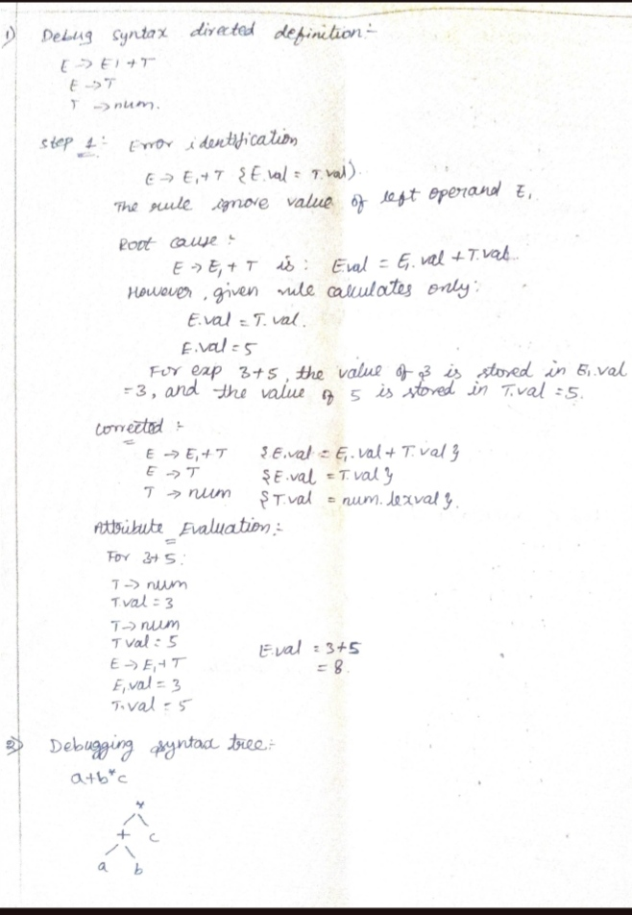
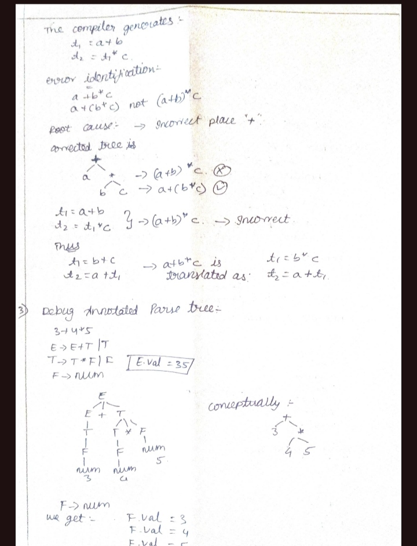

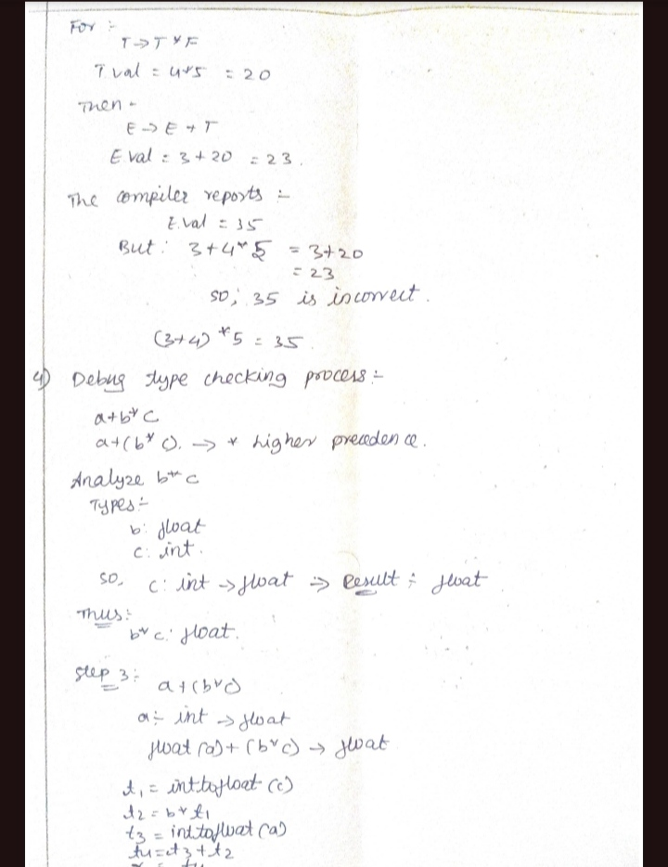

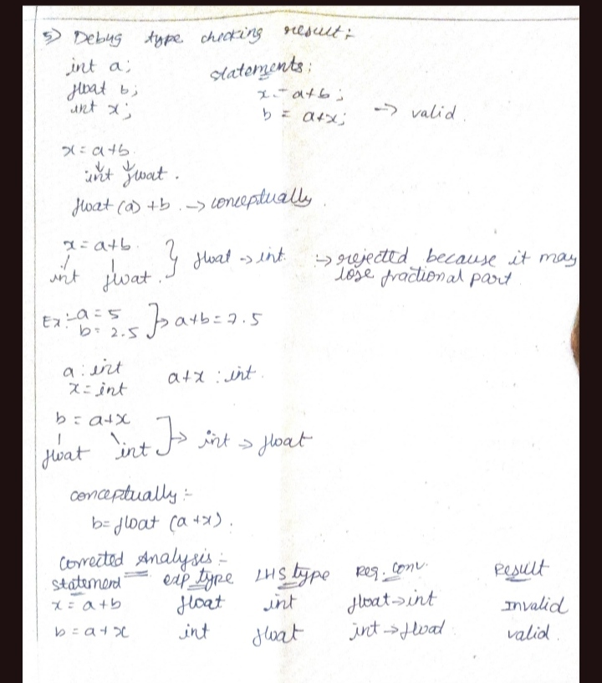

RUBRICS FOR CALCULATION

Criteria | Weightage | Level 4 – Exemplary | Level 3 – Proficient | Level 2 – Developing | Level 1 – Beginning
Understanding of Debugging Concepts | 25 | Thorough understanding; clearly identifies all key issues | Good understanding with most issues identified | Basic understanding; some issues missed | Poor understanding; problem not identified correctly
Error Identification | 25 | Effectively applies relevant concepts to analyze the case deeply | Applies appropriate concepts with minor gaps | Limited application of concepts | Fails to apply relevant concepts
Root Causes Analysis | 20 | In-depth analysis with strong reasoning and insights | Good analysis with logical reasoning | Basic analysis with limited depth | Weak or no analysis; lacks reasoning
Error Correction & Solution Design | 20 | Innovative, feasible solutions with strong justification | Logical solutions with adequate justification | Basic solutions with weak justification | Incorrect or no solution provided
Testing and Validation | 10 | Clear, well-structured, and easy to understand | Organized and understandable presentation | Limited clarity and structure | Poor clarity; difficult to understand

